**Abstract**

This report documents the design, manufacturing and performance analysis of a transformable desk, for the use of sitting and standing users. The transformation would be switch operated and a stepper motor will actuate the desk. The desk should be fully functional, capable of supporting the load of a laptop and some books within the bounds of compliance.

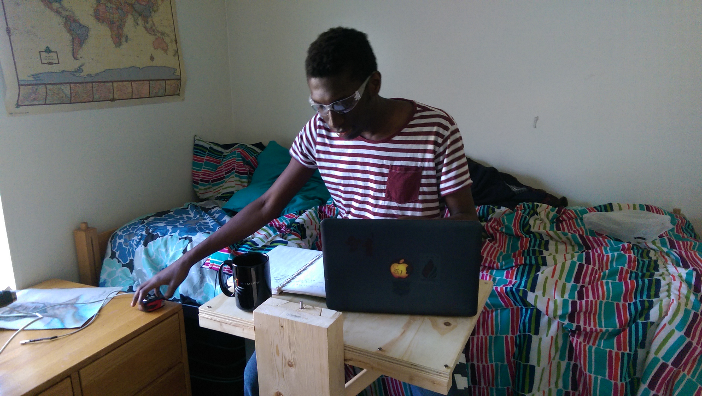

**Design**

There are several functional requirements that the desk has to fulfill. It has to be electronically actuated, switching between the sitting and standing positions. It must support the weight of a Macbook Pro and a few notebooks. It should be rigid, deflecting by a small amount when loaded. Finally, it should be built within a budget of $120. The FRDPARRC table is shown below:

|  |  |  |  |  |  |
| --- | --- | --- | --- | --- | --- |
| **Functional Requirements** | **Design Parameters** | **Analysis** | **References** | **Risks** | **Counter-Measures** |
| Electronically actuated | Stepper motor and leadscrew design | Torque, power analysis | PMD, datasheets | Cables, Connections | Cable ties, proper fastening |
| Support weight of items and person | Be able to handle 200N | Bearing and structure mechanics | PMD, Material Properties | ~ | ~ |
| Two positions | Two resting positions | Controls, Mechanics | PMD, Datasheets | ~ | ~ |
| Little deflection | Decrease error and deflections | Beam-bending, compliance analysis | Euler-Bernoulli Beam Theory, PMD | Increased weight, cost | Use better geometry and exercise wisdom |
| Within budget | Cost less than $120 | Recycle/Re-used materials | Re-use material sites, McMaster, Amazon | Might get inferior items | Exercise caution and wisdom |

Table 1: FRDPARRC Table of Desk

**Strategies**

Multiple strategies were investigated to complete this desk. Three strategies were broadly considered:

The floor desk strategy was first considered. It allows for a wider base and a heavier desk meaning a higher rigidity overall. However, the cost of material and cumbersome size of the desk makes this strategy less favorable.

This strategy had a smaller mechanism placed on top of an already existing table. Due to its smaller size, it would have a much lower cost.

The wall-mounted strategy was the selected strategy. It had moderate features: in terms of weight and cost, it would be between that of the tabletop and floor desk. It would have a superior rigidity due to the number of attachment point.

**Concpets**

For the wall-mounted system, two concepts were considered: a single rail, and a double rail. The double rail would provide more rigidity since the structural loop would go through two bearings. The cost however would go up for a dual rail system. It would also increase the complexity, as a timing mechanism would be required to move both carriages the same amount of displacement.

**Error**

A preliminary error budget was created and used to generate stiffness requirements. The budget is shown in the table below:

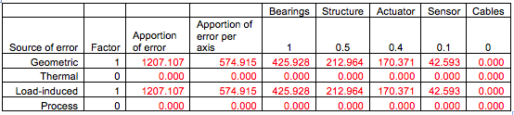

Table 2: Average error budgeted for axis. Calculated for 3 axes with a total allowable error of 2 mm.

A basic design for a single bearing table is shown in the figure below. Further analysis is conducted on this table to correctly size components and determine the feasibility of such a model.

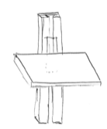

**Table**

The flat table section is a ½ in thick. In order to maintain the stiffness required, diagonals would be added between the carriage and table.

**Bearings**

A dovetail slider was envisioned for this table. The dovetail allows gravity preloading to provide lateral preload and stiffness. The main concern with the dovetail was the carriage slipping out. This would be either due to deflection laterally by loading, or rotation of the rails also by loading. Sizing the component of the rails such it wouldn’t deflect reduced the rotation of the rails. The deflection was similar reduced by sizing and material selection.

**Motor, Power Transmission**

The motor was chosen based on its holding load and power requirements. Buckling was the main concern with the leadscrew. Analysis reveals that a minimum diameter of about 6 mm will be enough to prevent buckling. Ball bearings will be used to allow rotation and will need specifically created blocks to support the leadscrew.

**Carriage**

The carriage will be a simple dovetail wedge. There will be a slot, intersecting the clearance shaft for the leadscrew. A nut will be situated in the slot, moving the carriage. The nut doesn’t need to be constrained in the lateral directions, but it will be axially contacted with the carriage by gravity preloading.

**Preload**

The entire system will be gravity preloaded. This would remove errors from manufacturing and will allow structural stiffness.

**Model**

Using compliance and error propagation models, the final sizing and dimensions were created. The final model of the desk is in the Figure below:

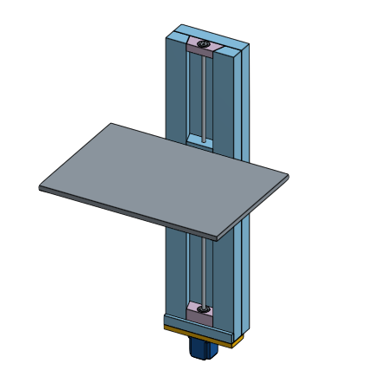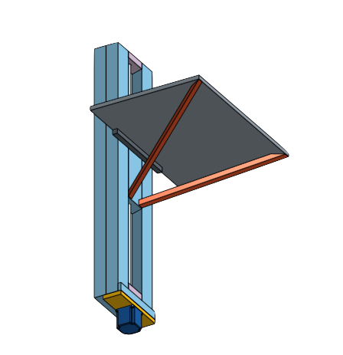

**Risks and Countermeasures**

The main concern is with body parts getting pinched in the slider mechanism. Guards and billows can feasibly be added, but this would make the overall structure bulky and complex.

**Manufacturing**

Most of the materials were purchased from local hardware stores, Home Depot and McMaster-Carr. A few of the structural elements were recycled from older projects.

|  |  |  |  |
| --- | --- | --- | --- |
| **Item** | **Quantity** | **Unit Price** | **Total Price** |
| 2 x 8 Fir Lumber [8 ft] | 1 | $6.49 | $6.49 |
| 2'x 4' Plywood [1/4"] | 1 | $10.22 | $10.22 |
| Microcontroller | 1 | - | - |
| Motor Controller | 1 | $20.00 | $20.00 |
| Stepper Motor | 1 | $30.00 | $30.00 |
| Powersupply | 1 | $10.00 | $10.00 |
| Leadscrew | 1 | $18.97 | $18.97 |
| Spider Coupling | 2 | $3.78 | $7.56 |
| Rubber Intermediate | 1 | $2.47 | $2.47 |
| Wood screws | 1 | - | - |
| Fasteners | 1 | - | - |
| Bearings | 4 | $6.90 | $27.60 |
| Wood Glue | 1 | $8.00 | $8.00 |
|  |  | **Total:** | $141.31 |

Table 3: Bill of Materials. Items without price were recycled from older projects

**Table**

This is the flat surface of the desk. The 2'x 4' piece of plywood is cut into 3 pieces. These pieces are glued and then clamped to maintain the force necessary for the glue.

**Slider and Carriage**

The lumber was first be planed for flatness. In order to cut the angles needed by the dovetails, a table saw was used, setting the blade to the appropriate angle. The error from this process will be included in the final readjustment of the error budget and the reiteration process. The sliders and bearings were cut at the same session to minimize fabrication error.

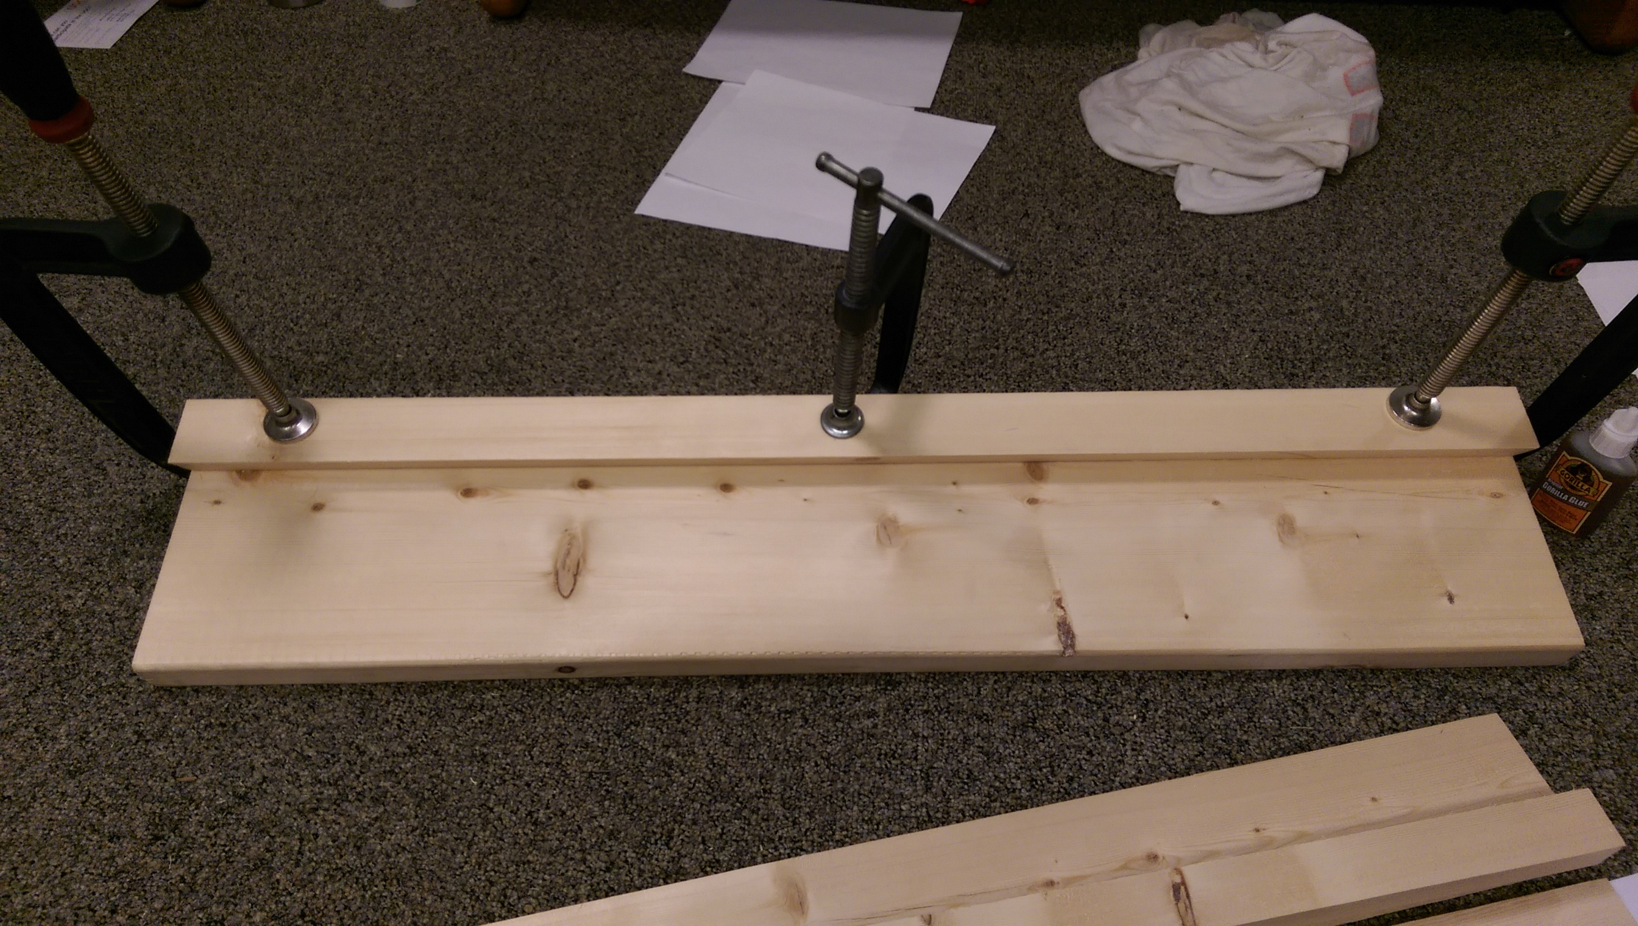

The first keeper was clamped and glued to create the bearing. The slider was inserted with a piece of paper between the angles of the slider and bearing to ensure tight tolerance. The second keeper was then glued to the bearing and clamped; it will clamped to the bearing and to the slider to ensure the right tolerance.

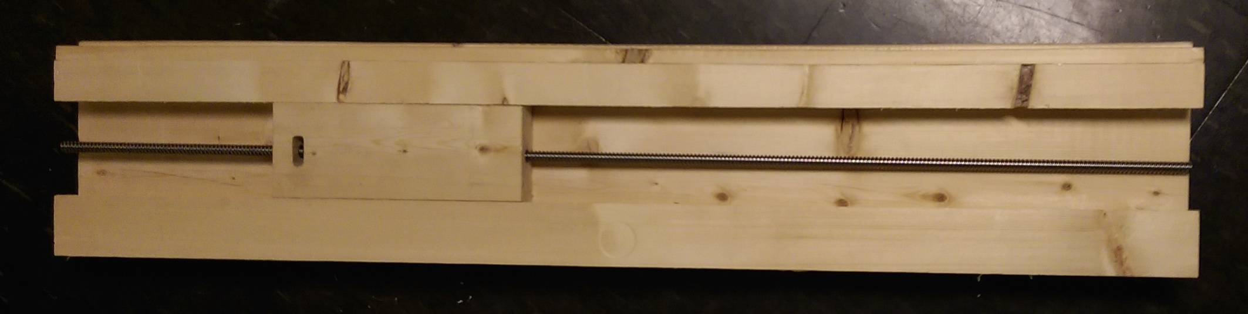

**Diagonals**

Based on the pre-calculated angles, the table saw was adjusted and the diagonals were cut. They were then screwed into the carriage and the table. The lateral piece was also added to the base of the desk and carriage.

**Leadscrew**

Both ends of the leadscrew were turned down in according to the design. The feed speed was adjusted in order to increase the overall accuracy of the manufacturing process.

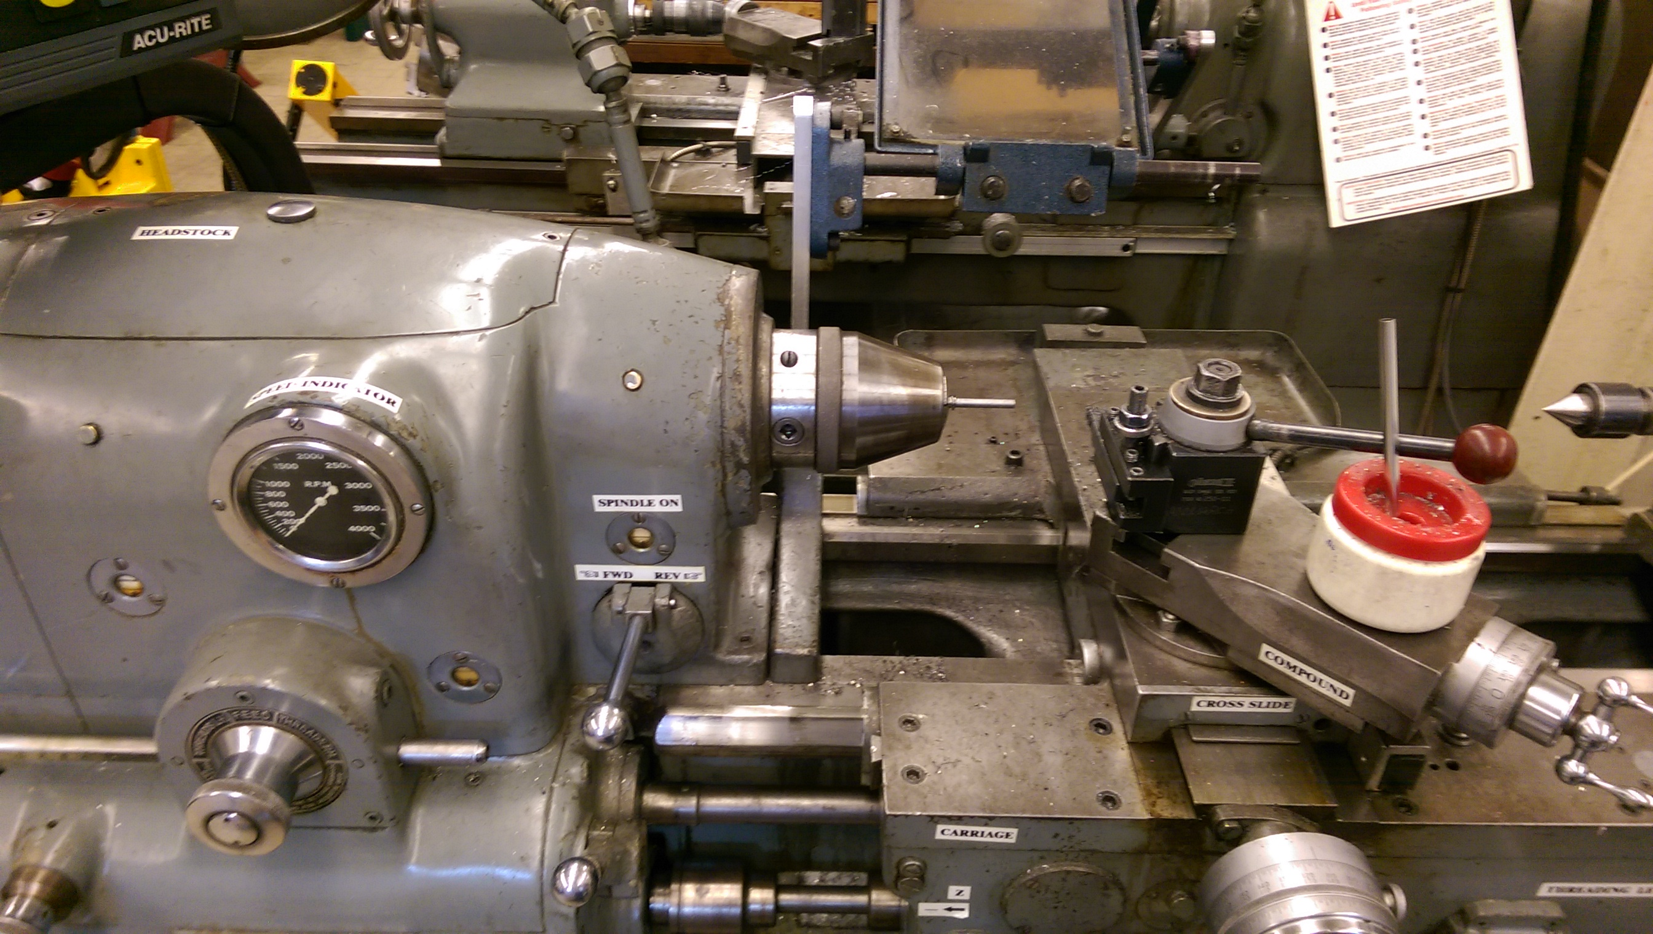**Motor Mount**

The motor mount was made from a piece of lumber. It will be aligned and screwed to the bottom of the bearing. The spider coupling used should be able to handle any misalignment.

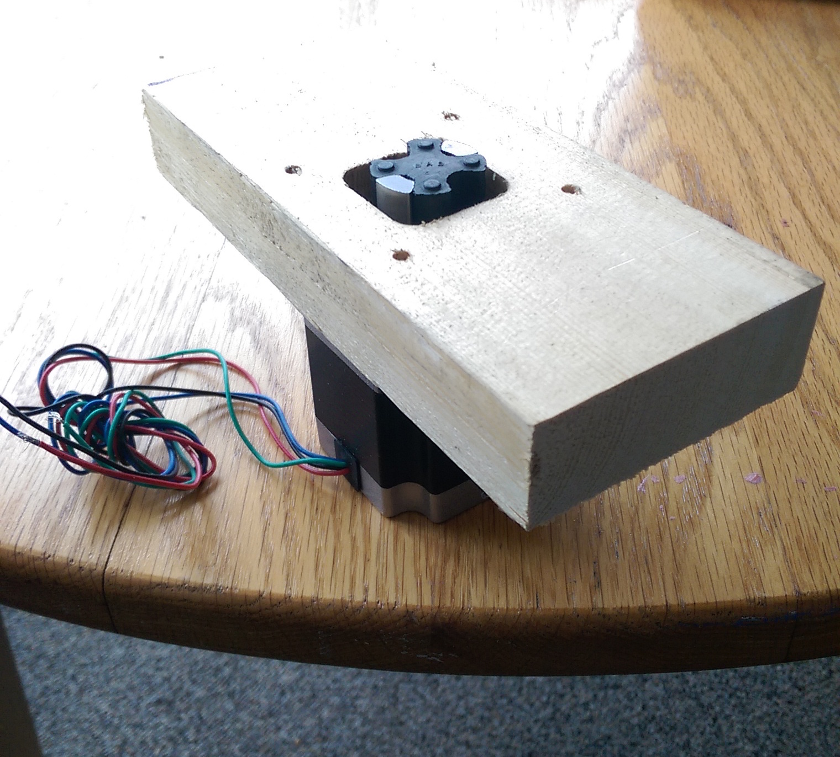

**Bearing blocks**

The bearing blocks were created from the center cut piece of wood in order to use part matching to minimize errors. Following the drawings, the blocks were made ensuring that the bearings fit appropriately in them.

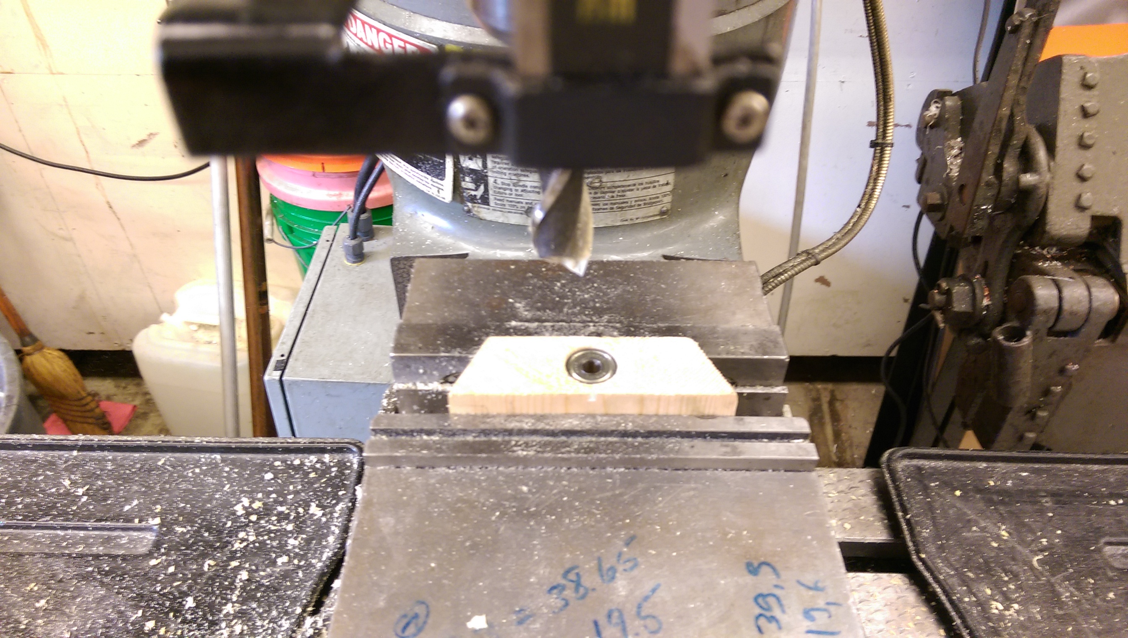

**Performance**

**Error**

Due to inadequate clamping, there was a larger than expected clearance between the carriage and the slider. The error was about 1.5 mm. To minimize this error, a preloadable carriage could be used. The rail could also be redone, including this error in calculations.

**Stiffness**

The table feels remarkably rigid. This is due to the diagonals included, as well as the ¾ inch table thickness.